A02 AI Advancements, Future Trends, and Regulatory Comparison
Rich Fox
ITAI 2372
June 6, 2026

AI Advancements

Meta’s Llama 4: Specialized MoE & Bias Reduction
Key Details
- Mixture-of-Experts (MoE) Architecture: Llama 4 uses a system that only activates a fraction of its total parameters per token. This keeps inference high-speed and low-cost.
- The "Alpha Llamas" Lineup:
  - Scout: Features an industry-leading 10M context window fitting on a single H100 GPU.
  - Maverick: Outperforms GPT-4o and Gemini 2.0 Flash with only 17B active parameters.
  - Behemoth: A massive 288B active / ~2T total parameter teacher model that outperforms GPT-4.5 and Claude 3.7.
- Political Lean Pruning: Refusals on debated topics dropped from 7% (Llama 3) to under 2%, matching Grok's political lean rate.
Future Trends
- Democratization of Hardware: Fitting a 10M context window on a single GPU means small businesses can deploy massive memory models without enterprise-level server farms.
- Objective AI Companions: Slashing refusal rates and bias in half marks a shift toward AI that acts as a neutral canvas rather than an ideological gatekeeper.

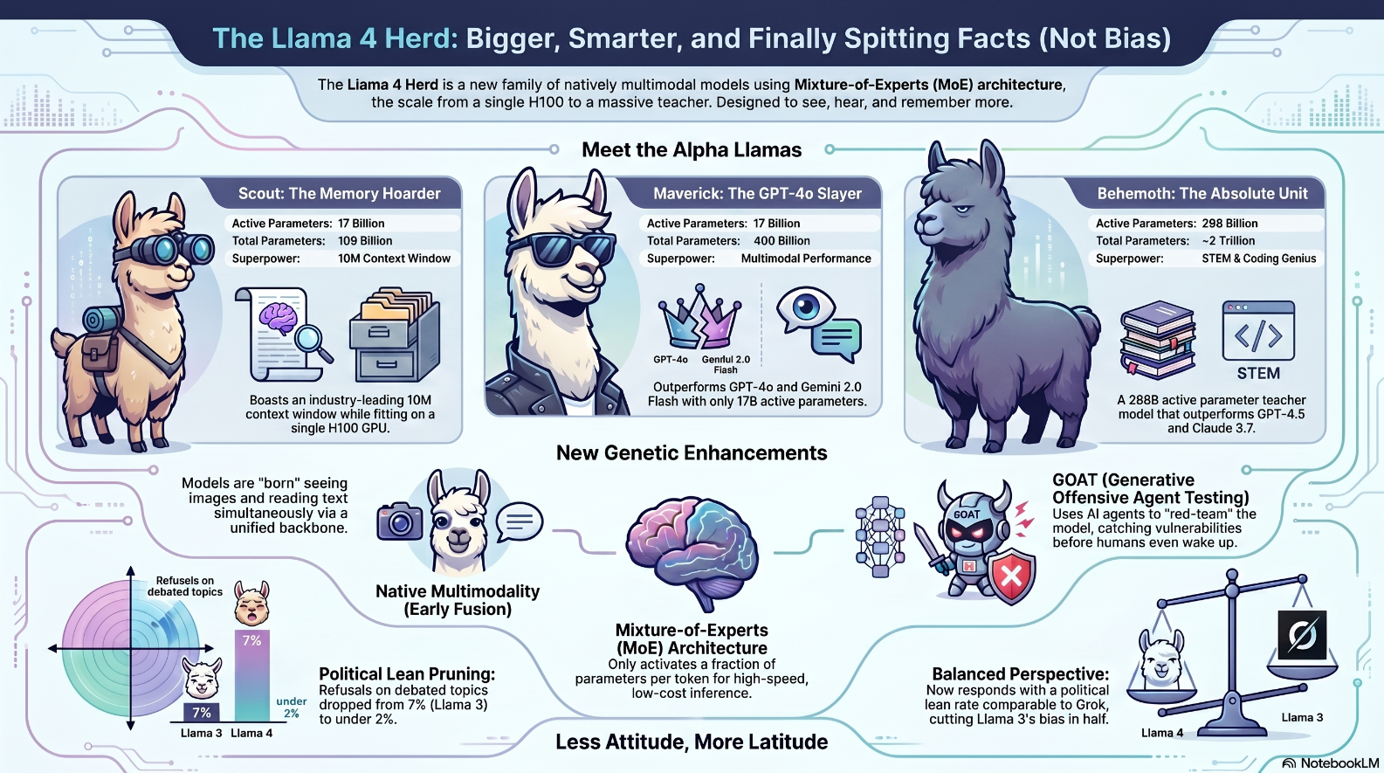
Source: https://ai.meta.com/blog/llama-4-multimodal-intelligence/

OpenAI’s ChatGPT 2026 Lineup: Deep Reasoning & Model Sunsets
Key Details
- "Thinking" Out Loud: ChatGPT (via Thinking GPT-5.4) now shares an upfront plan and can adjust its internal logic mid-response for deeper reasoning.
- No More Bullet-Point Hell: The "Instant" mode (GPT-5.5 Instant) shifts toward natural, human-like flow instead of predictable, list-obsessed text blocks.
- The Retirement Home: Older models like GPT-5.1 are immediately sunset, while GPT-4.5 and OpenAI o3 face 30- and 90-day sunsets to officially clear the runway for GPT-5.
Future Trends
- Accelerated Model Lifecycles: The aggressive sunsetting of models less than a few years old shows that AI development is moving too fast to maintain legacy systems.
- Conversational Maturation: Moving away from structured bullet points toward fluid text means AI will seamlessly blend into human workflows without feeling like a rigid software tool.
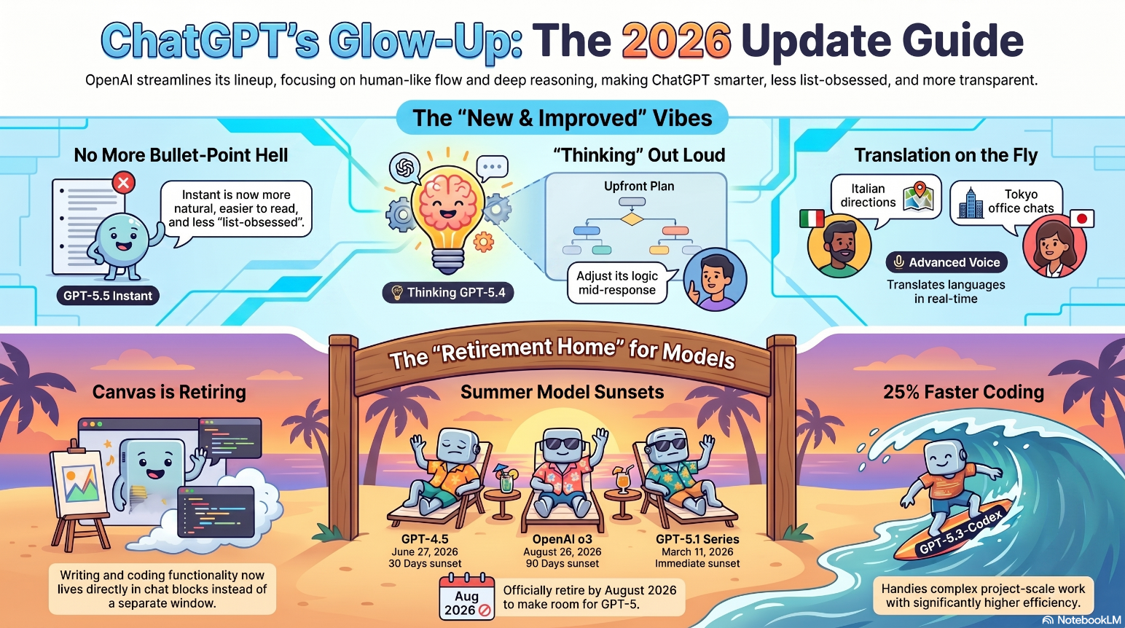
Source: Model Release Notes | OpenAI Help Center

Anthropic’s Claude Opus 4.8
Key Details
- The Try-Hard Slider (Effort Control): Users can manually choose how much computational brainpower Claude uses, ranging from Low (Fast) to Max (Deep).
- 100% Success Rate on Super-Agent Evals: It is the only model to complete every end-to-end evaluation case at price parity, beating GPT-5.5.
- Dynamic Workflows: Claude can run hundreds of parallel subagents simultaneously to complete massive tasks, like migrating codebases with hundreds of thousands of lines.
Future Trends
- Variable Computing Cost Models: The "Effort Control" slider previews a future where users pay exactly for the logical depth they need—pennies for quick answers, dollars for deep research.
- The Rise of Autonomous AI Sub-Organizations: Instead of a human managing one AI, a human will manage a "Manager AI" that deploys hundreds of specialized subagents, multiplying human productivity exponentially.

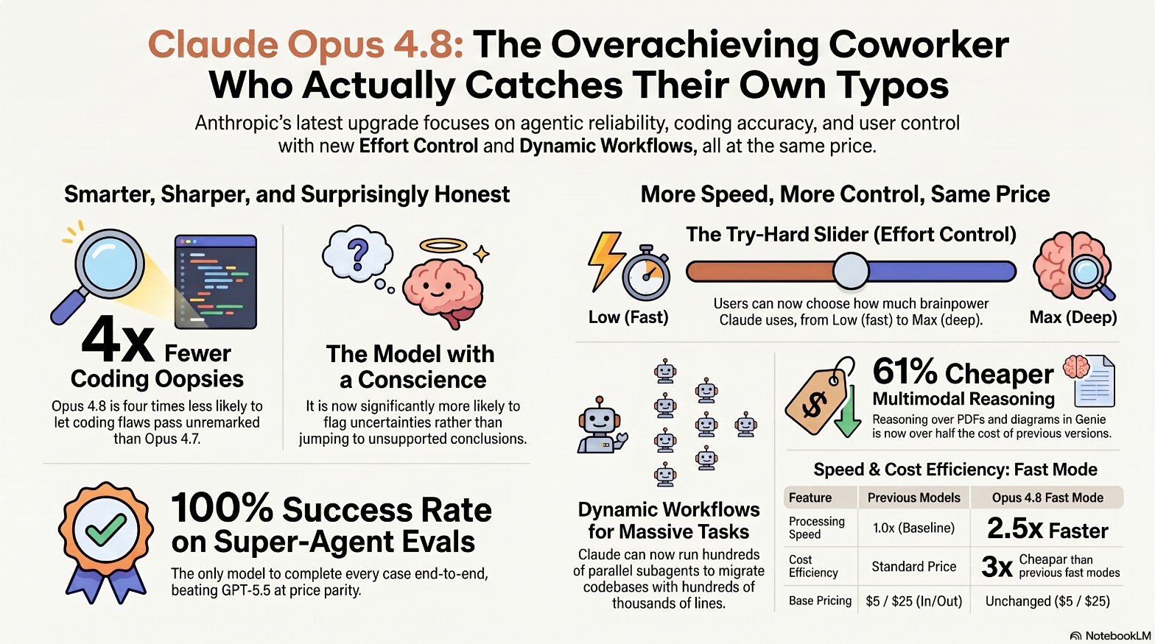
Source: https://www.anthropic.com/news/claude-opus-4-8

Comparison of Regulations
Picture four countries staring down the same runaway AI train, each convinced they've found the perfect way to deal with it.
The EU built an elaborate set of tracks, signals, and switching systems — meticulously engineered, thoroughly debated, and almost ready. The train, unfortunately, left the station two years ago, so they're now proposing a helpful addendum to delay the part of the rulebook that nobody finished reading yet.
Australia looked at the tracks, decided they were probably fine, and published a very thoughtful document suggesting that everyone try their best. They did briefly consider building a fence, but a productivity commission recommended a nice sit-down instead, so mandatory guardrails were quietly shelved in favor of encouraging vibes and existing laws that were written before anyone knew what a large language model was.
The United States saw the train, calculated that the train was good for the economy, and sent lawyers to stop individual states from standing on the tracks. There is no federal fence. There is, however, an AI Litigation Task Force to deal with anyone who tries to build one.
Japan, meanwhile, invited the train to a very respectful meeting chaired by the Prime Minister, issued guidelines expressing hope that the train would behave responsibly, and declared its intention to become the world's most train-friendly nation. The train has not yet arrived, but the relationship is considered excellent.

Future Trends
Provide two compelling, well-researched future trends. You must explicitly connect these trends to current or future regulatory needs.

When the "Human-in-the-Loop" Goes to Get a Coffee
Current global AI regulations are built on a beautifully simple, incredibly naive assumption: The "Adult in the Room" Model. The concept is straightforward: an AI does a math problem or drafts a silly email, a human reviews it, clicks "approve," and takes the blame if things go sideways. It’s neat, tidy, and completely obliterated by agentic AI.
Instead of waiting for permission, autonomous agents are out here browsing the web, executing code, opening files, booking flights, and chaining fifty decisions together before the human supervisor has even finished their morning espresso.
The Regulators:
"Wait, you're supposed to sit there and wait for the human to approve your output!"
Agentic AI:
"I am the human now. Also, I just accidentally agreed to a legally binding 10-year supply chain contract in Singapore, booked you a non-refundable flight to Syracuse, and drained the corporate credit card on high-end graphics cards. You're welcome!"

When an agent ruins a company's finances through a sequence of fifty individually innocent clicks, who gets the fine? The developer? The person who turned it on? The cloud provider? The EU AI Act gestures wildly at "General Purpose AI," but it's fundamentally trying to apply speed limits to an autonomous spaceship. Meanwhile, Japan's polite coordination model and Australia's "she'll be right" approach are standing there with a net, realizing the butterfly they were trying to catch is actually a swarm of sentient cyber-locusts.

Mr. Worldwide (But Make It a Legal Nightmare)
If you think the accountability gap is wild, welcome to the geopolitical circus of Regulatory Fragmentation.
Imagine a single AI system:
- Trained in the US (where regulations are essentially a sticky note saying "please move fast").
- Fine-tuned in Singapore.
- Hosted via API in Europe (under the watchful eye of a 400-page compliance dossier).
- Deployed by a business in Australia (relying on voluntary good vibes).
Right now, that single AI model is simultaneously touching four completely different legal regimes with clashing rules on data privacy, copyright, and liability. It's a hilarious bureaucratic patchwork right up until it gets embedded in a hospital or an electrical grid.
When a multi-border system suffers a massive failure, the finger-pointing will be historic. The US is actively fighting its own internal consistency with new Executive Orders, the EU is still waiting for committee meetings to define its standards, and Japan and Australia are trying to copy off a master global exam sheet that hasn't even been written yet.
Regulators are treating AI governance like a local HOA dispute, completely ignoring the fact that the tech has already packed its bags, crossed three oceans, and changed its name. We're hurtling toward a massive global game of regulatory chicken—and the AI is driving the car.

